**A**

**REPORT**

**ON**

**PYTHON DJANGO**

***Submitted by***

**PATEL VRUDITKUMAR DASHARATHBHAI (181250107045)**

**SUMMER INTERNSHIP (3170001)**

**BACHELOR OF ENGINEERING**

***in***

**Computer Engineering (7th Sem)**



**Shree Swaminarayan Institute of Technology**

**Gujarat Technological University, Ahmedabad**

**2021-2022**

**Shree Swaminarayan Institute of Technology**

**At: Near EDI & Sardar Patel Ring Road Circle Gandhinagar to Ahmedabad Airport Highway, Bhat, Gandhinagar, Gujarat 382428**

CERTIFICATE

*This is to certify that the project reports, submitted along with the project entitled* ***“*PYTHON DJANGO*”*** *has been carried out by* ***PATEL VRUDITKUMAR DASHARATHBHAI (181250107045)*** *under my guidance in SUMMER INTERNSHIP of* ***Bachelor of Engineering*** *in* ***Computer Engineering (7th Semester)*** *of Gujarat Technological University, Ahmedabad during the academic year* ***2021-22****. These students have successfully completed activity under my guidance.*

|  |  |  |
| --- | --- | --- |
| **Prof. Guide Name**  Internal Guide  Computer Engineering  SSIT, Bhat, Gandhinagar |  | **Prof. Vijaykumar Gadhavi**  Head of Department  Computer Engineering  SSIT, Bhat, Gandhinagar |

**ACKNOWLEDGEMENT**

The successful completion of my summer internship named “**PYTHON DJANGO**” stands on the constant encouragement, guidance, and support, both technical & personal of many individuals.

However, it would not have been possible without the kind support and help of many individuals and institutional. We would like to extend our sincere thanks to all of them. We are highly indebted to our internal guide **Guide Name (Internal)** for their guidance and constant supervision as well as for providing necessary support in the summer internship. This project work could not have been completed without the expert guidance **Guide Name (Internal)**who shown me proper path and direction of work.

They opened for me the offer of knowledge from repository of their experience. They have been encouraging me throughout my project work which increased my confidence and gave me the strength of working hard to achieve my target in time. This has impelled me to express my sincere gratitude to my project coordinator **Guide Name (External)**.

At the same time, I would like to thank my Head of the Department **Dr. Vijaykumar Gadhavi** for his kind cooperation and support. I would also appreciate his keen interest in helping me and his regular guidance throughout the project. I would also like to thank all the staff members of my department for their cooperation and help me when asked for. I am also grateful to all my colleagues for helping me with all their resources and knowledge they could, as when required.

**ABSTRACT**

The main objective of this project is to make a user-friendly website. The project also focuses on making the work of users easier. The project provides almost all types of analysis at one place. This facility saves the time of user as there is no need to wander at other websites for analysis of data. Our project also focuses on providing facility of various file formats at one place. Our projects also focus on data visualization of analysed data in various graphical formats. This project also provides various data operations like slicing, merging etc so that the format of data can be improved.

**INDEX**

|  |  |  |
| --- | --- | --- |
| **SR**  **No.** | **CONTENTS** | **PAGE NO** |
| **1.** | **Introduction**  1.1 Project Summary/ Task Summary  1.2 Purpose (If Project)  1.3 Scope (If Project) | 6 |
| **2.** | **About Technology** | 7 |
| **3.** | **System Requirements and Specifications** | 9 |
| **4.** | **TASK/ PROJECT SCREENSHOT WITH CODE** | 10 |
| **5.** | **Certificate from Company (Akash Technolabs)** | 49 |
| **6.** | **Conclusion** | 50 |

1. **Introduction :**

For newly introduced subject “ **Summer Internship (3170001)”** by GTU, I joined one reknowned Ahmedabad based IT company named “**Akash Technolabs”** to learn **“Python Django”** from scratch. The duration of the internship was about 2 weeks. In this time interval, I learned lots of things regarding Web Development using Python.

In fact, I got benefit of having brillient external guide as well as internal guide of my college. I explored all the aspect of Django frame-work in detail.Even I got a chance to clean up my existing knowledge of Pythom multi-purpose programming language.

The working mode of this internship was Online. So, it was the main pluse point of this internship. Because we all are aware with devastating outbreaks of global pendamic **COVID-19**. Thus I was not required to visit Akash Technolabs physicaly. I coud be more productive while staying in my favourable work environment that is my home. In this way I felt that I contributed my self to the society by keeping my self isolated in my home.

In this internship , I used to learn new concepts of python and its frame-work Django on daily bases. Meanwhile, I had to submit my daily task on **GitHub Repository**.

My GitHub URL : <https://github.com/Vruditdp>

At some point I took help of my internal guide and external guide in order to clear my understanding about some complex concepts of django. For example Administrative panale and Data base connectivity.

1. **About Technology :**

It is needless to describe that we encounter countless new technologies in this digital world on regular bases.So as a intern I did have wide range of choices to learn something valuable and important in terms of my future. But at the end of the day I decided to go for Django.

Pyhton is a multipurpose programming language. It is belived that python is the most effective and easy to learn as it is identical with English language. Python is being used in every nuke and corner of this fast moving digital world. Web development is not an exceptional for this. Python does have two frameworks to work in web development.

* + **Flask**
  + **Django**

**Flask** is used to build light-weight and less dynamic web pages. In fact it is recommended if you want to build small-scale website. But in current scenario every one wants to own very attractive, user friendly and dynamic website. As a result, Flask is becoming less popular gradualy.

On the other hand, **Django** caters all the features that are required by most of stakeholders with ease. Django possess quite extra capabilities compared to Flask. Perhaps that is the main reason why every web developer is moving on django. There are numerous benefites of adopting django for web development. The first and foremost is that django provide in-built “Admin panale” which is fully features loaded. Thus developer doesn’t have to invest his resources in development of admin panale. Admin can perform **CRUD** operations in that in-built panale. Ultimately it reduce the time and cost of the final product.

Secondly, we can connect any sorts of database with our project as django offers connectivity with wide range of databases which are listed as below:

* MySQL
* PostgreSQL
* Oracle Database
* SQL Server
* Maria DB
* IBM Db2
* SQLite
* Microsoft Access
* OrientDB

Moreover, django has large community and it is free as well as opensource.

Apart from it django has huge documentation which can be found on following URL : <https://docs.djangoproject.com/en/3.2/>

We can download django at : <https://www.djangoproject.com/download/>

Some famous websites which are built using django are :

* [Disqus](https://disqus.com/)
* [Instagram](https://www.instagram.com/)
* [Knight Foundation](https://www.knightfoundation.org/)
* [MacArthur Foundation](https://www.macfound.org/)
* [Mozilla](https://www.mozilla.org/)
* [National Geographic](http://www.nationalgeographic.com/)
* [Open Knowledge Foundation](https://okfn.org/)
* [Pinterest](https://www.pinterest.com/)
* [Open Stack](https://www.openstack.org/)

1. **System Requirements and Specifications**

If we talk about system requirements and specification than we do not need to worry because django projcet can be done on any operating system ( MacOS, Windows, LINUX).

It doesn’t require high specs physical machine that has very costly processor and ram. Our work can be completed on intel i5 processor with 4 GB of ram.

But ofcourse python version 3 must be installed on our machine. Afterwards we can install django using pip or pip3 package manager.

Only we have to run the follwing line of code on CMD or Powershell :

pip install Django==3.2.4

we can get latest development version by this command :

git clone https://github.com/django/django.git

In order to work in django very comfortably, we should have basic knowledge of **python** with understanding of **OOPs** concepts.

Further more we are supposed to have grip in **HTML** and **CSS**. **Javascript** makes it wonder if we know that .

In addition for working in big projects we would need understanding of **HTTP** protocol, **Session management, Cookies handling** and **Rendering**.

If our project is quite big than we also need knowledge regarding **database connectivity** and **database management**. Deep knoledge of any database like **MySQL** or **Oracle** is recommended in idle scenario.

1. **Task/ Project Screenshot with code**

As this internship was on online mode, we used to learn something new daily and we had to perform given task and upload it on GitHub repository.

My GitHub repo URL : <https://github.com/Vruditdp/Summer_Internship>

I performed each and every task given by my external guide and uploaded it on my GitHub repository. I was given to perform some tasks related core python so that my guide can evaluate my existing knowledge about python. Later on I was given to perform task on django itself. The tasks were really amazing.

Some tasks were complicated but having execellent guidence by both internal and external guide, I completed all the given work on time.

All the task with respective screenshots are described as below:

1. **Registration Form using HTML & CSS**

* On the very first day of internship, I made one registration form using HTML and CSS.
* I also add some beautiful animation between SignIn and SignUp page at the same time with back-ground image.
* Here is the screen shot of my code :

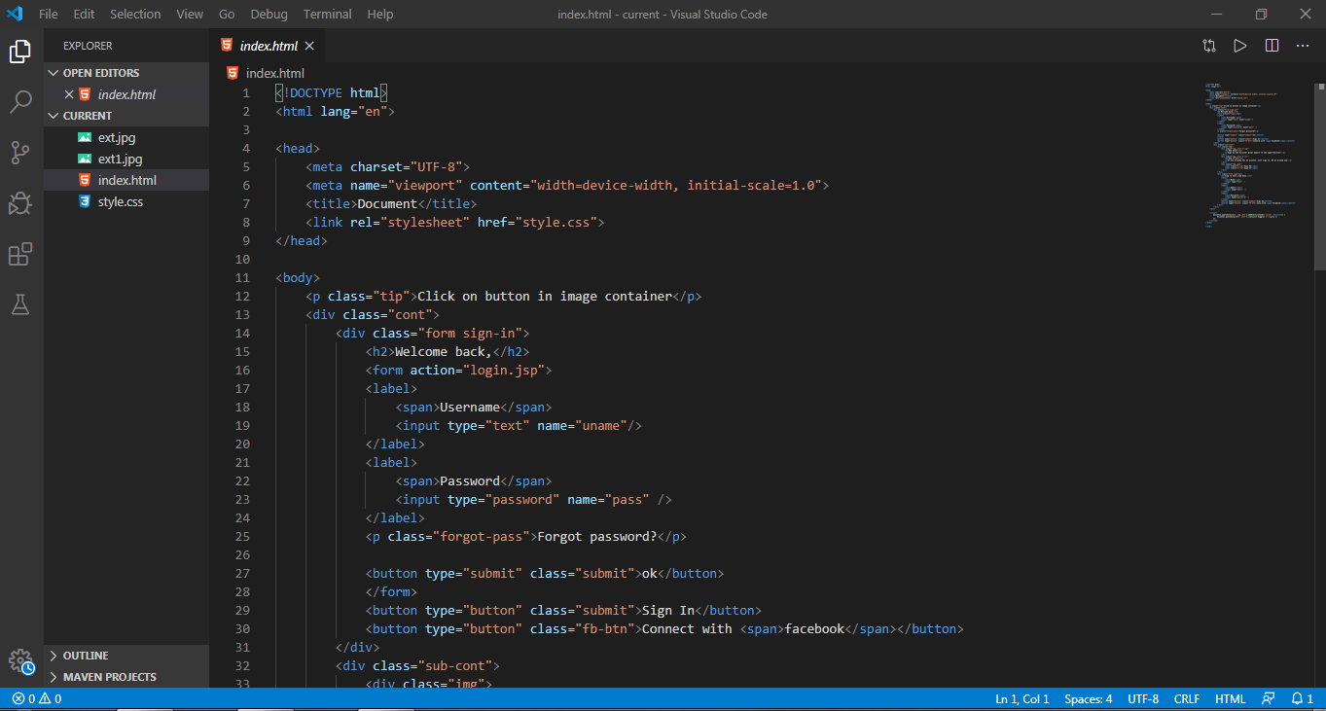

Output :

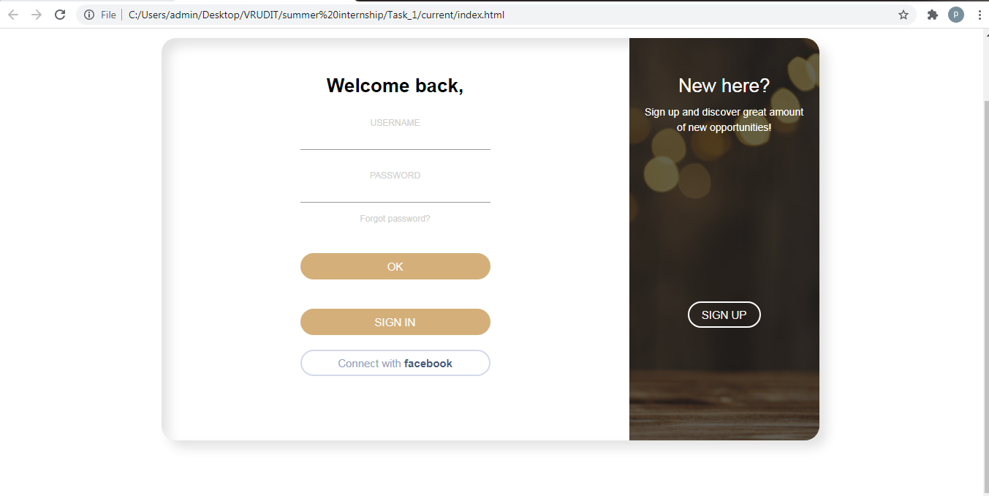

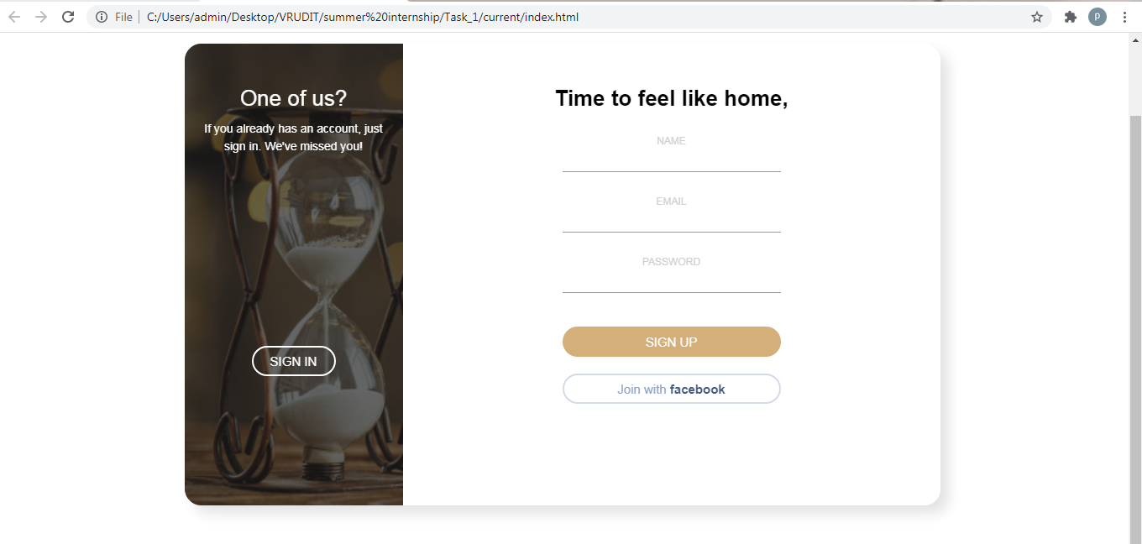

**(2). Basics of Python programming language :**

On second day , I was given to perform some basic operation of python language.

It includes :

* Comment
* Print()
* Variable declaration
* Type(). Isinstance()
* List, dictionary
* Slicing of list and sting

Here are some screen shots:

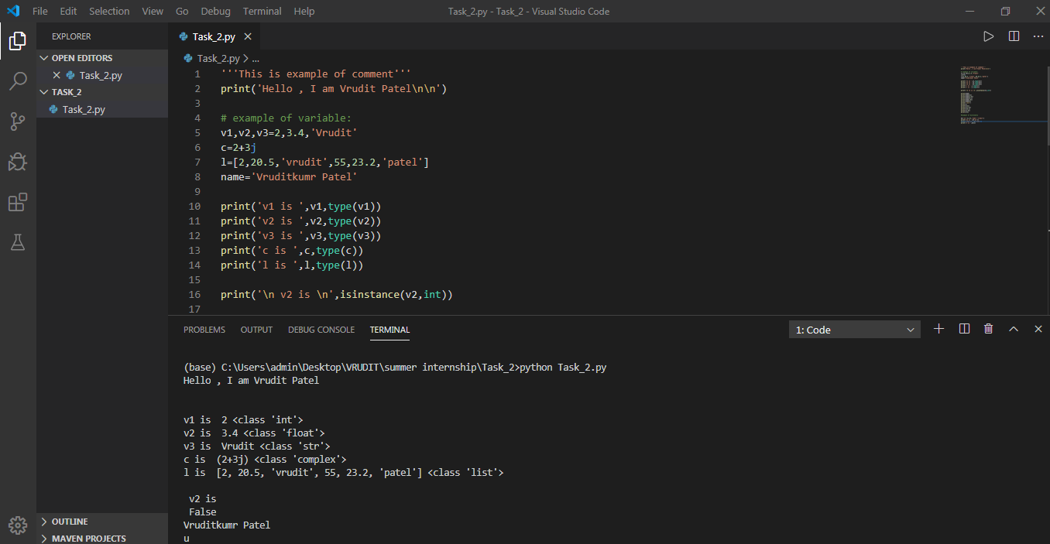

**OUTPUT :**

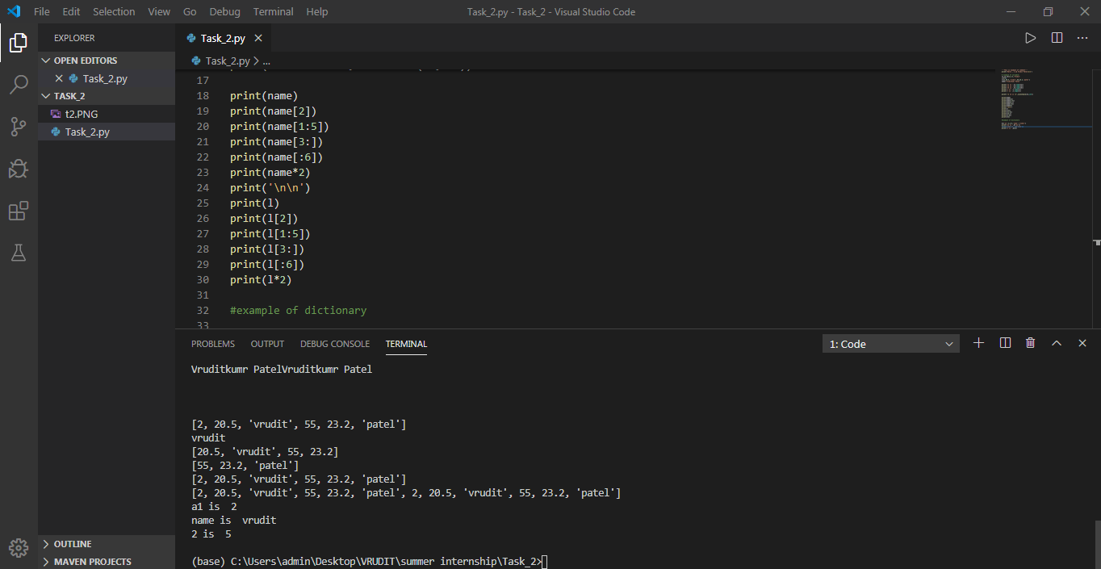

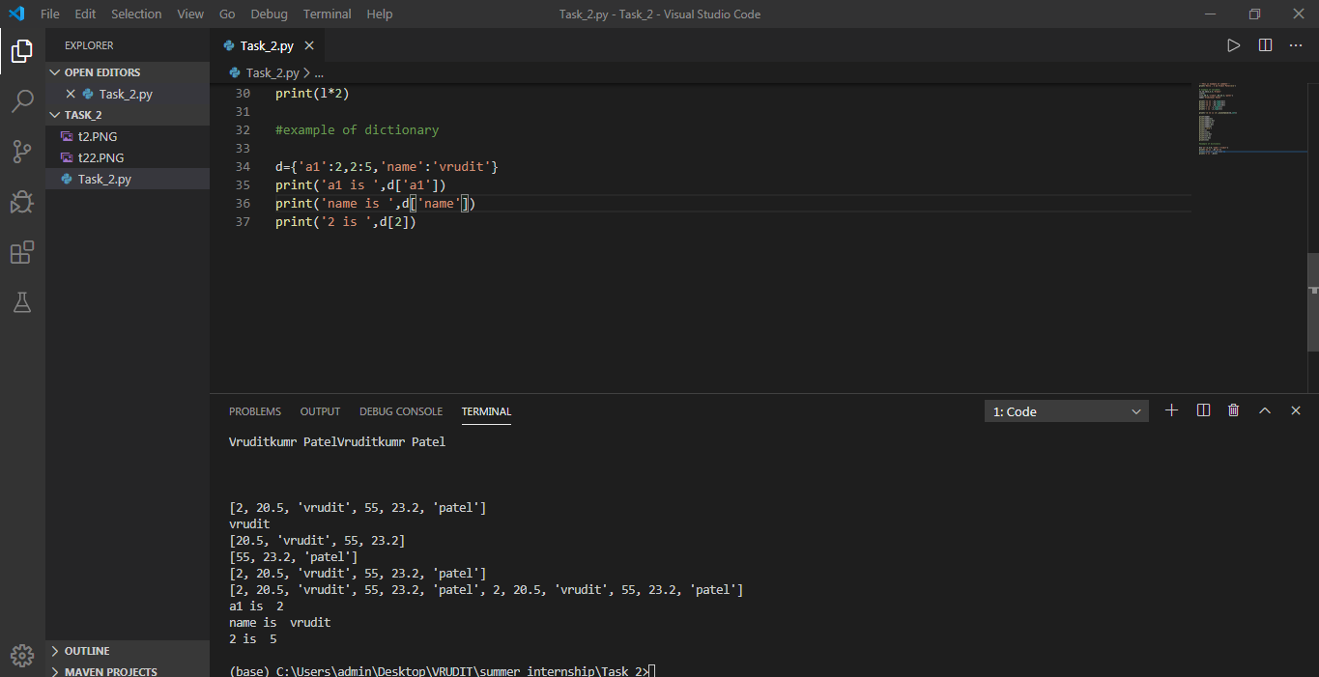

1. **Conditional statements, Input from user and basic operation on variables :**

On the third day, we were given to perform various operation on variables that are taken by user.

We have to implement Conditional statements like :

* If
* If … Else
* Elif
* While
* Do … While

Here are some screen shots of tasks :

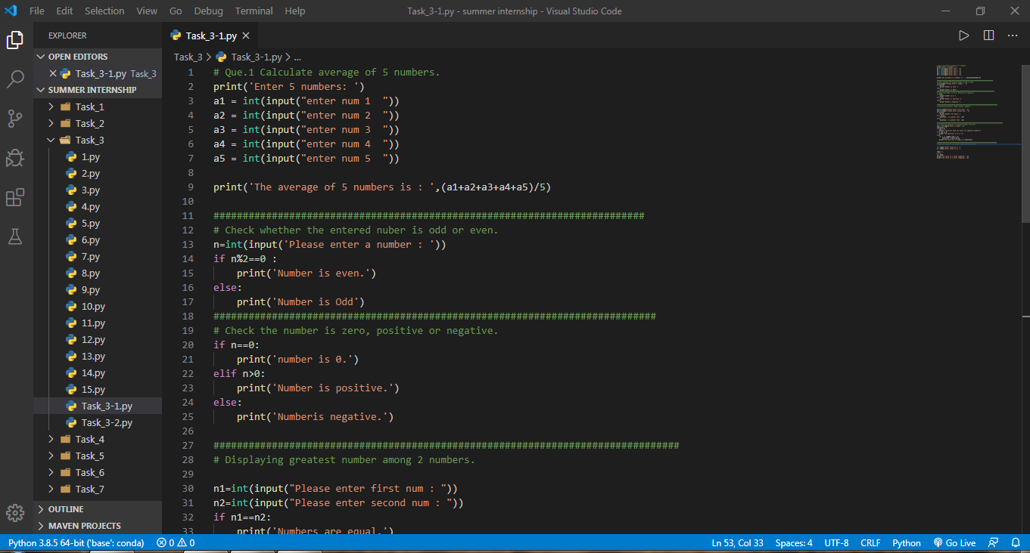

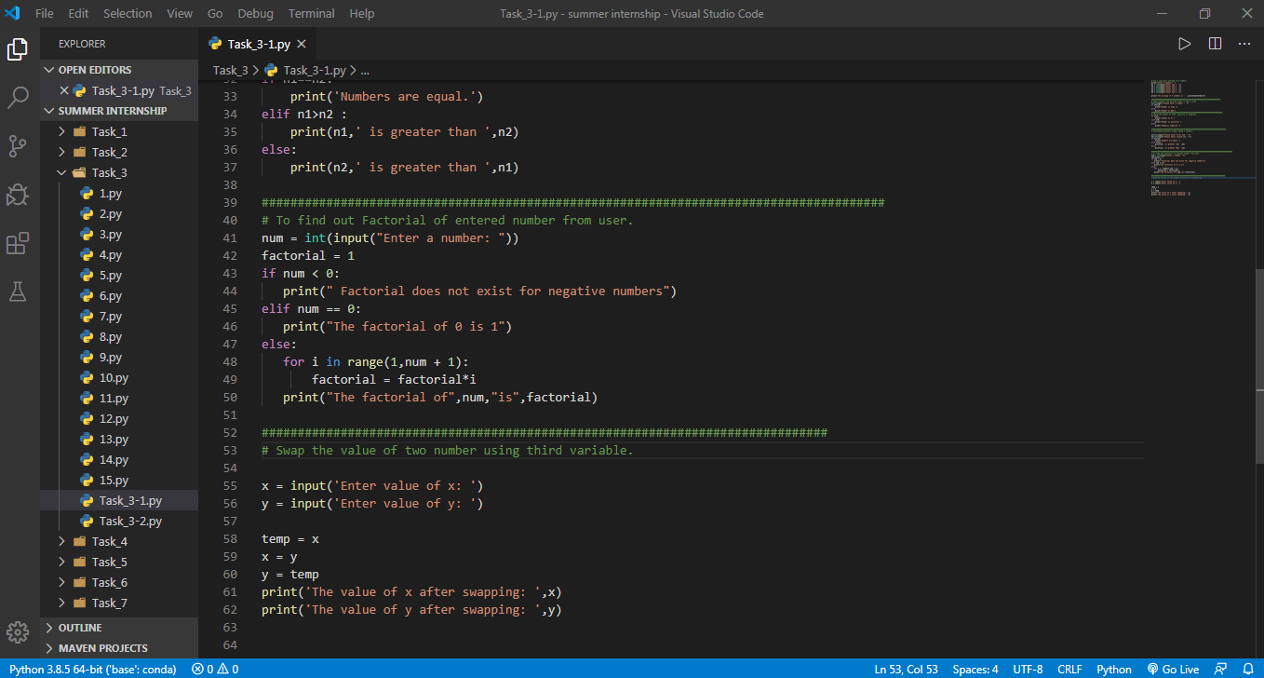

**OUTPUT :**

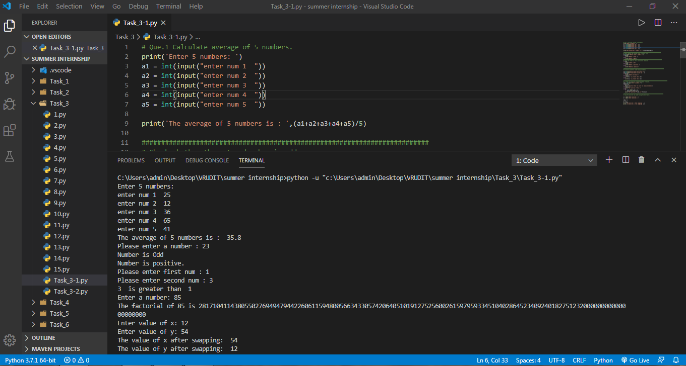

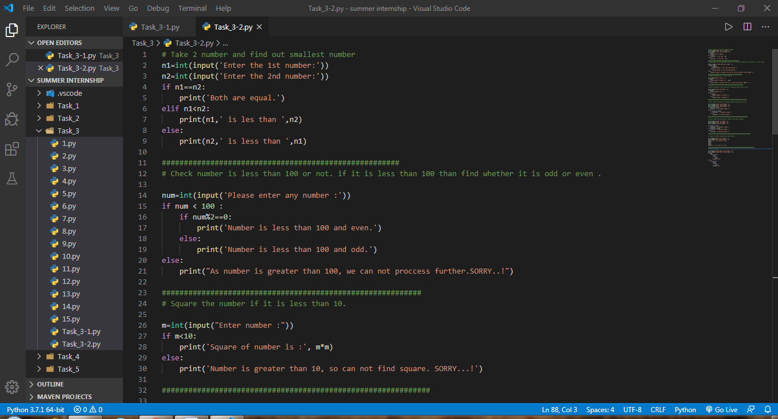

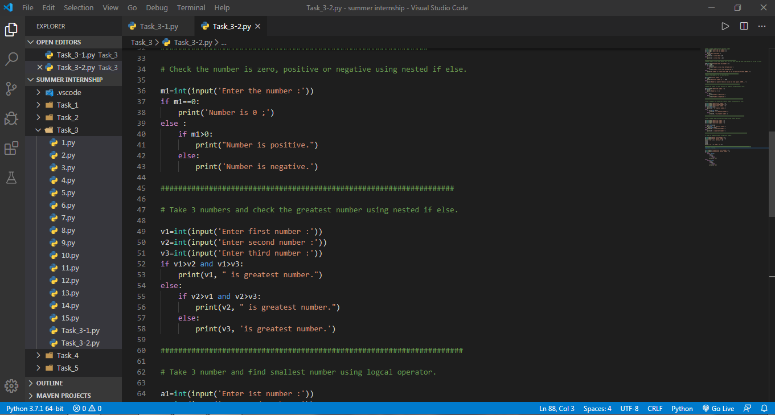

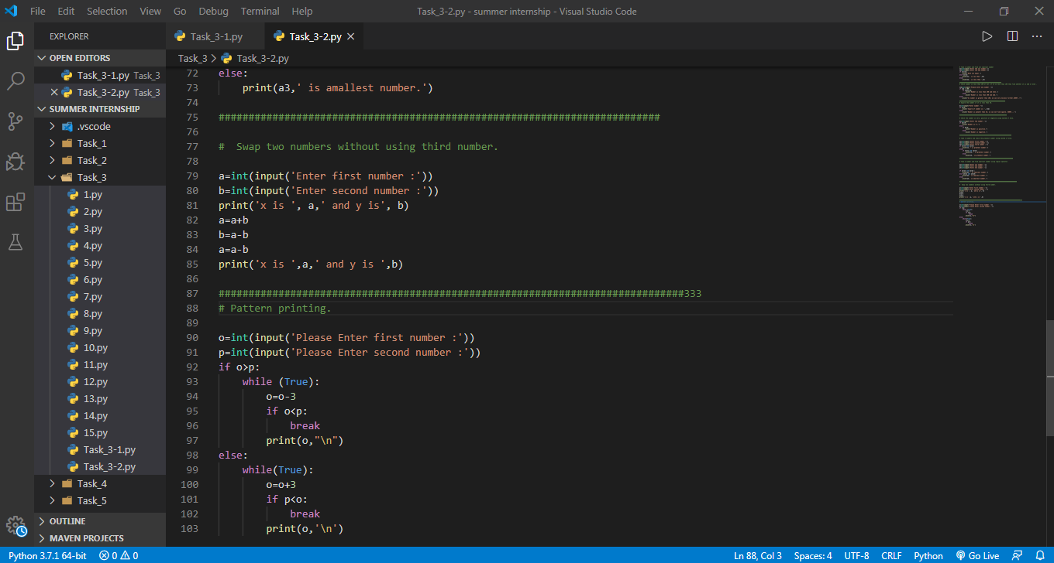

**OUTPUT :**

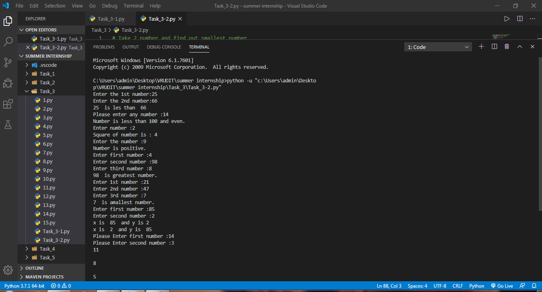

**(4). Arithmatic & Logical Operators and Functions**

On that day we learnt very crucial topic of Python – **Functions** .

We did some practical of different kind of functions .

* + function with arguments
  + function without arguments
  + function with arguments and return type.
  + function with arguments but from another module.
  + function from another arguments without arguments
  + function with arguments and return type from another module

Apart from this , I also learned different kind of Operators.

* + Comparison
  + Arithmatic
  + Logical
  + Special Operators ( "is" and "in" )

Here are some screen shots :

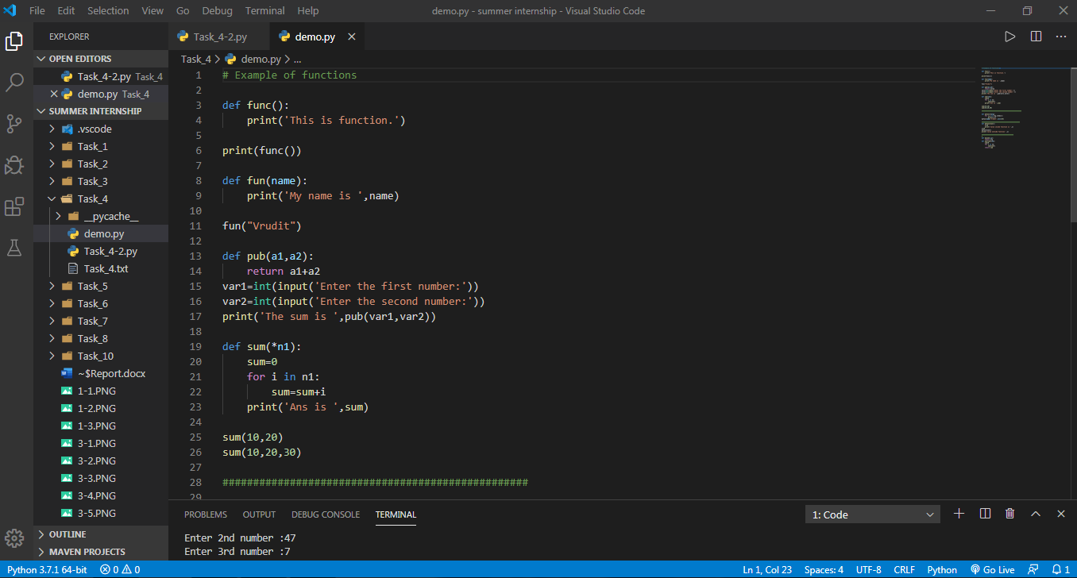

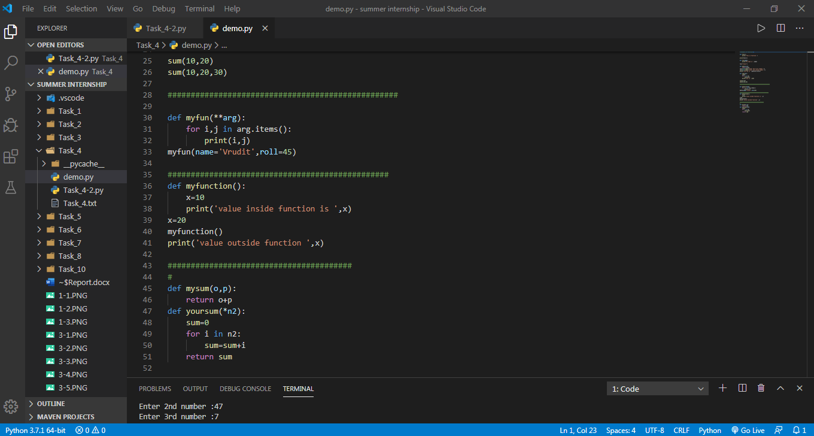

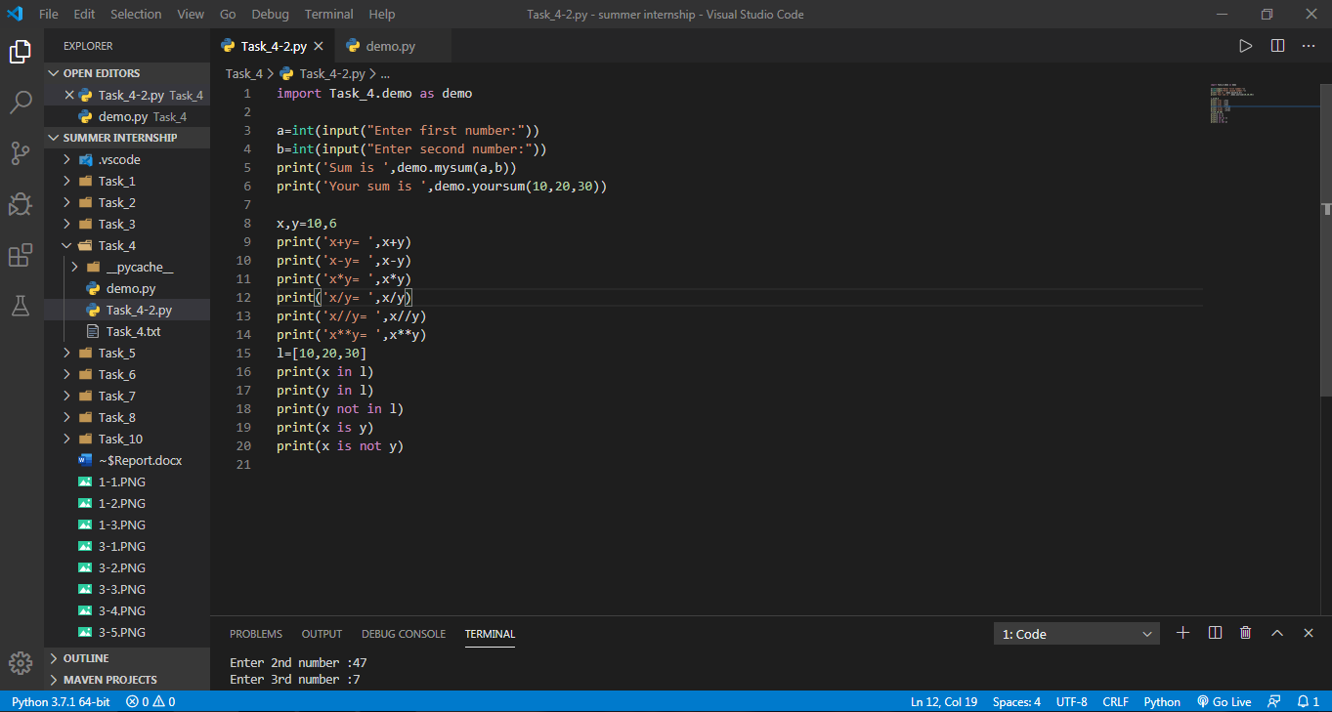

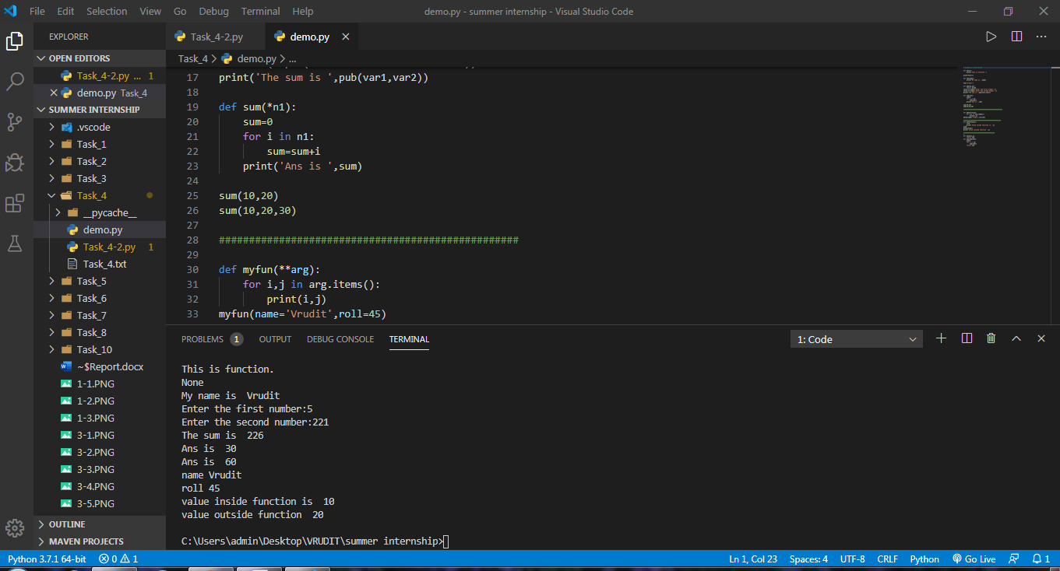

Output :

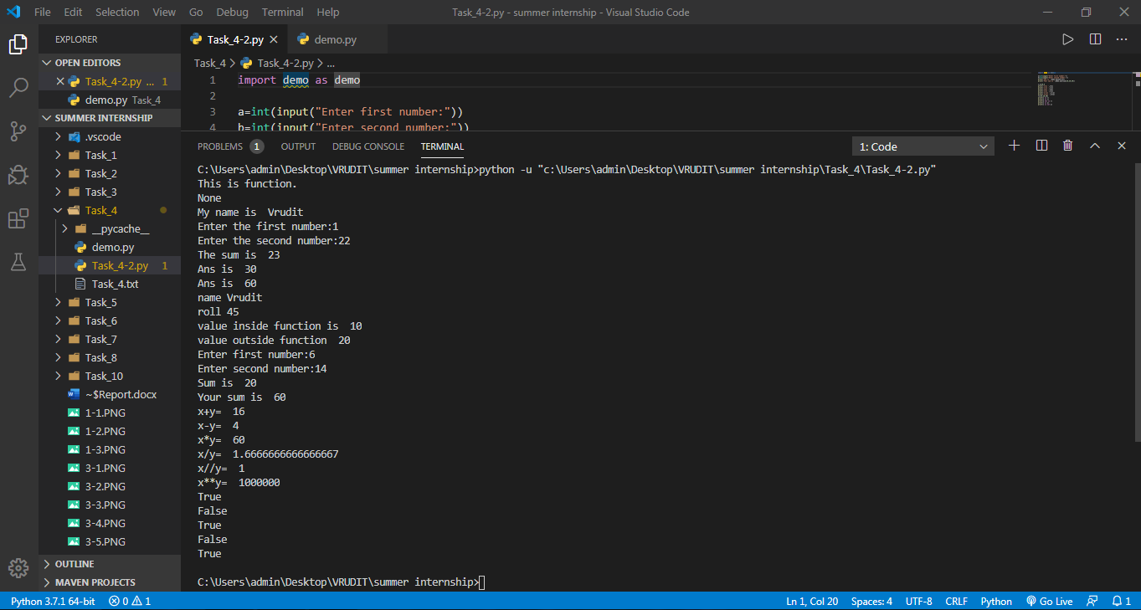

**(5) . Problem Solving using Functions. ( OOP’s )**

* We were to solve some problems with the help of OOP’s concepts.

Those problems were :

1. Create a class cal1 that will calculate sum of three numbers. Create setdata() method which has three parameters that contain numbers. Create display() method that will calculate sum and display sum.

2. Create a class cal2 that will calculate area of a circle. Create setdata() method that should take radius from the user. Create area() method that will calculate area . Create display() method that will display area

3. Create a class cal3 that will calculate simple interest. Create constructor method which has three parameters .Create calInterest() method that will calculate Interest . Create display() method that will display Interest.

4. Create a class cal4 that will calculate square of a number. Create setdata() method which has one parameters that contain number. Create display() method that will calculate sum.(Function should return value)

5. Consider an employee class, which contains fields such as name and designation. And a subclass, which contains a field salary. Write a program for inheriting this relation.

6. Create a class cal5 that will calculate area of a rectangle. Create constructor method which has two parameters .Create calArea() method that will calculate area of a rectangle. Create display() method that will display area of a rectangle.

7. Create a class cal6 that will calculate area of a square. Create setdata() method that should take length from the user. Create area() method that will calculate area . Create display() method that will display area .

8. Write a program with use of inheritance: Define a class publisher that stores the name of the title. Derive two classes book and tape, which inherit publisher. Book class contains member data called page no and tape class contain time for playing. Define functions in the appropriate classes to get and print the details.

9. Create a class called scheme with scheme_id, scheme_name,outgoing_rate, and message_charge. Derive customer class form scheme and include cust_id, name and mobile_no data.Define necessary functions to read and display data.

10. Create a arith class. The class should have a parameterized constructor and methods to add, subtract and multiply two numbers and to return the answers.

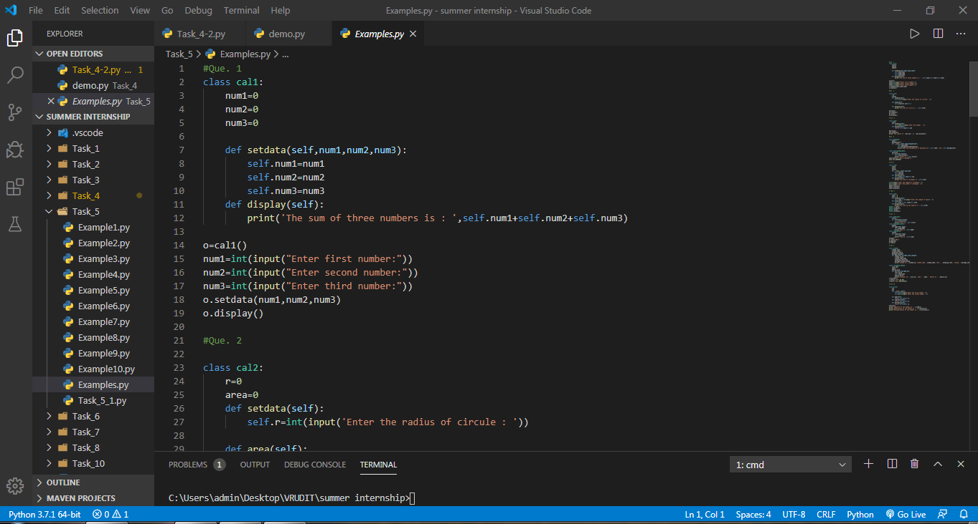

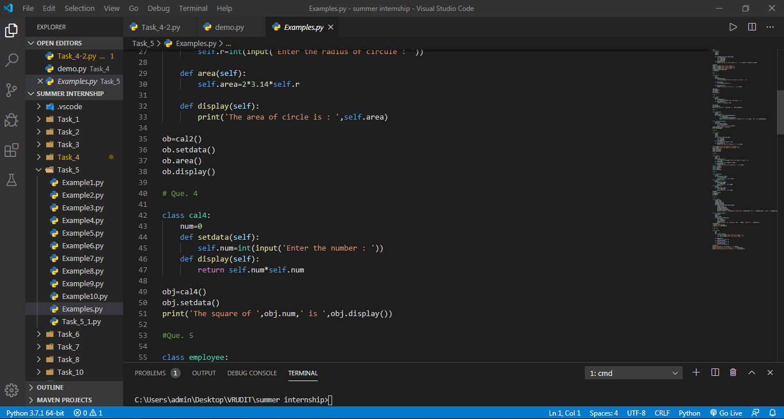

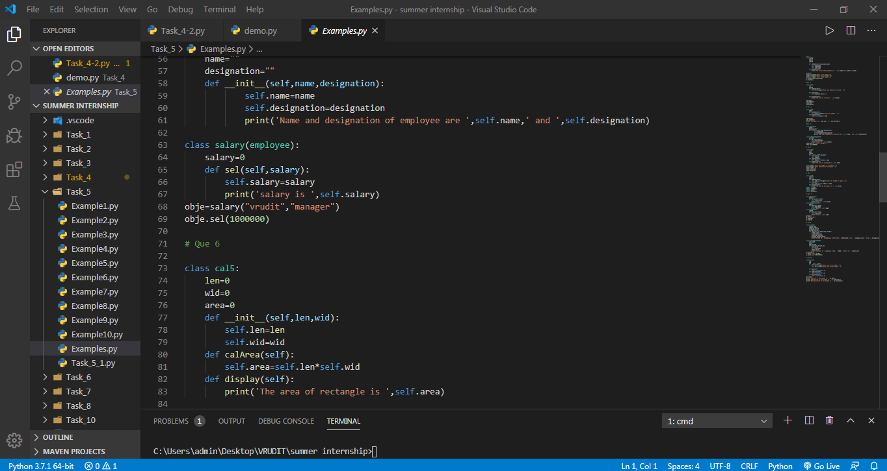

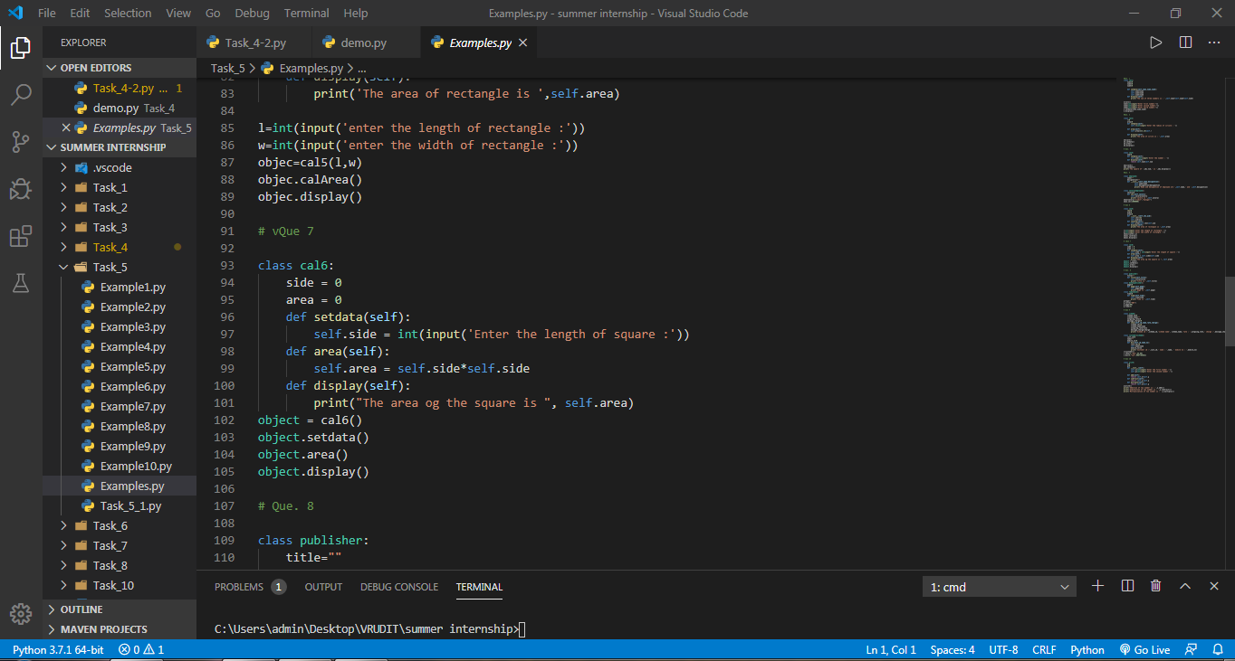

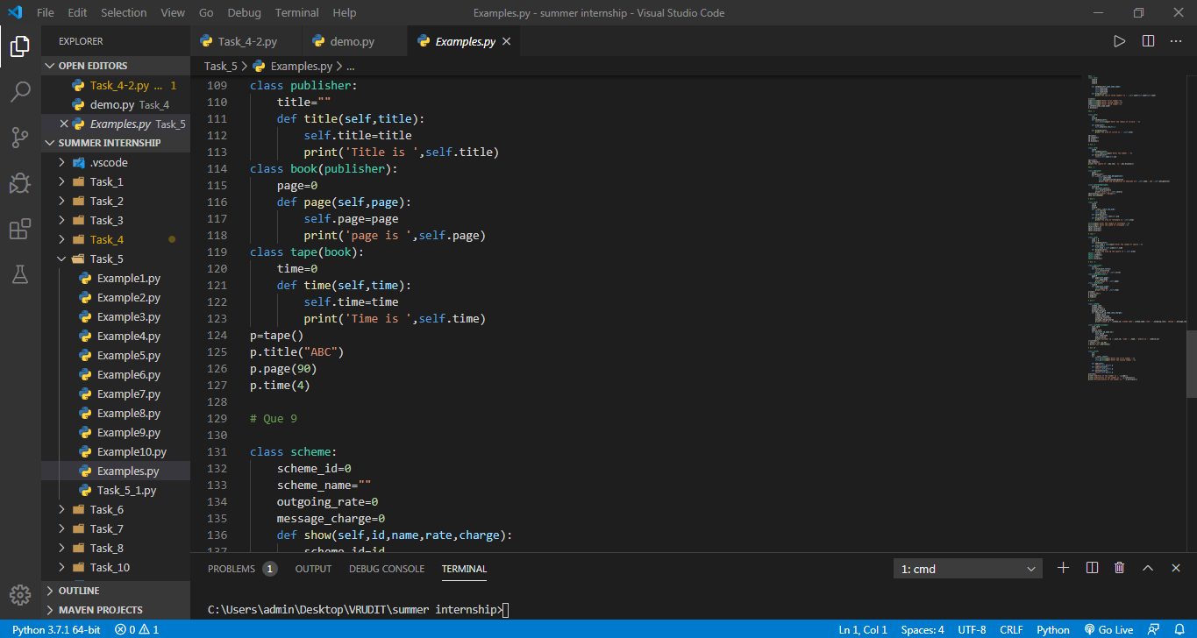

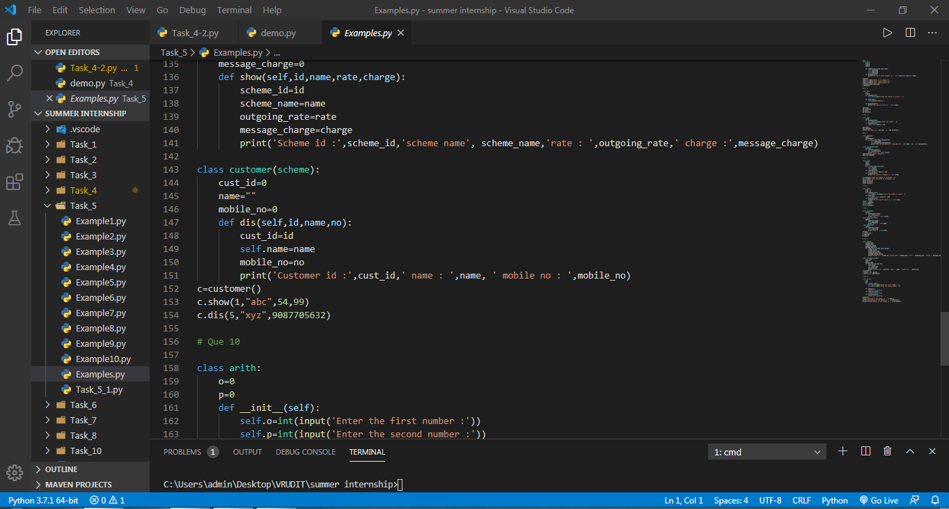

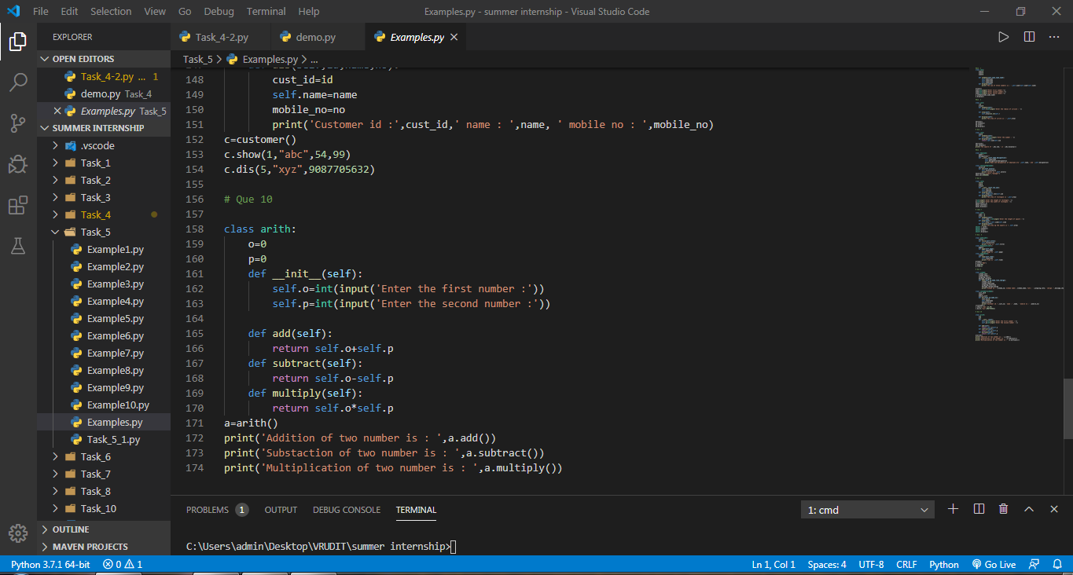

**NOTE** : Here I have run all functions via single file. So I got output on single terminal consol.

**OUTPUT :**

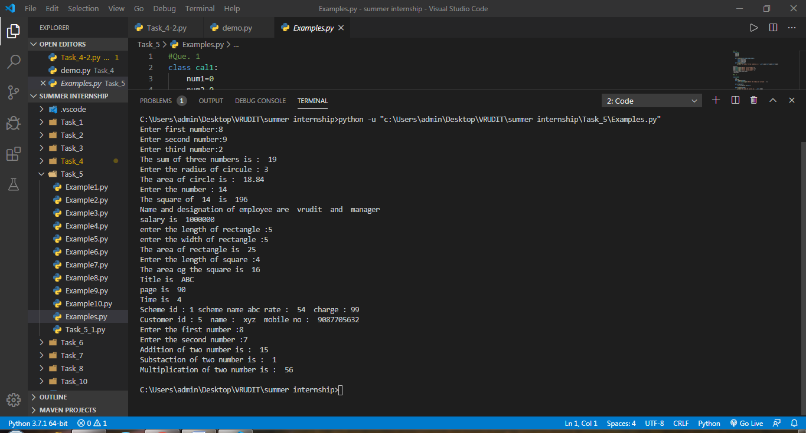

**(6). CRUD Operation in Python.**

* **CRUD** Operations are the most fundamental concepts of any scripting language. i.e Java, Python, Ruby, PHP etc.
* We learnt how to implement CRUD in python.
* In this programe Implement Database connectivity with MySql using MySql connector.

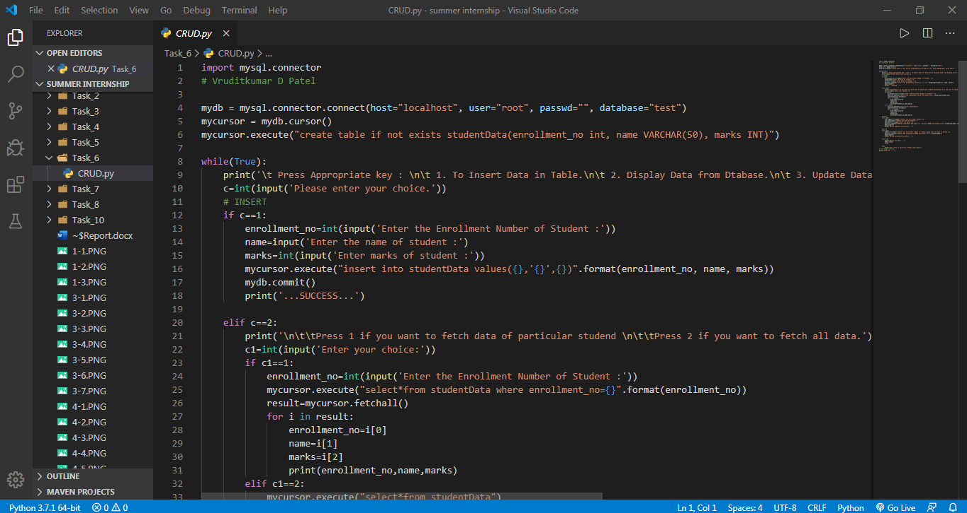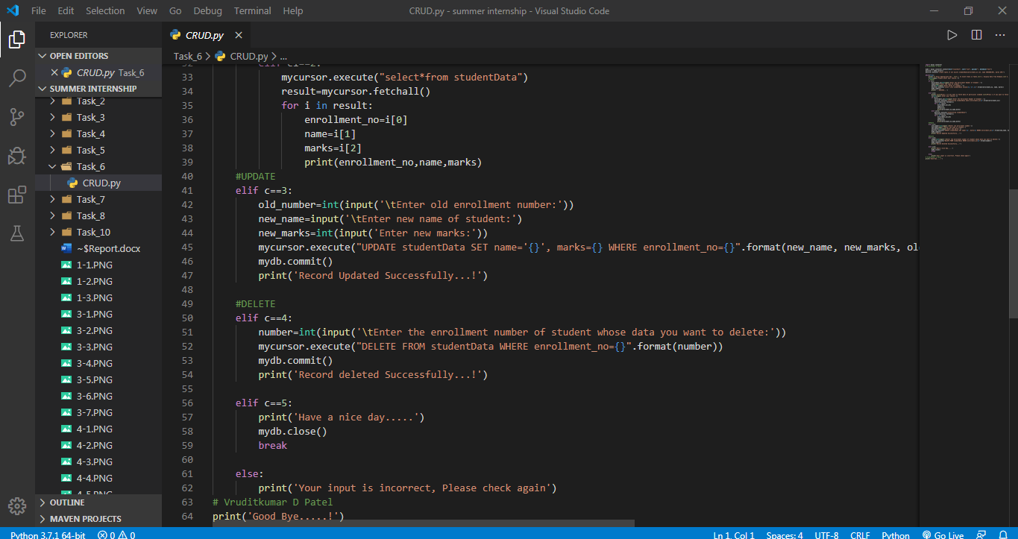

Output :

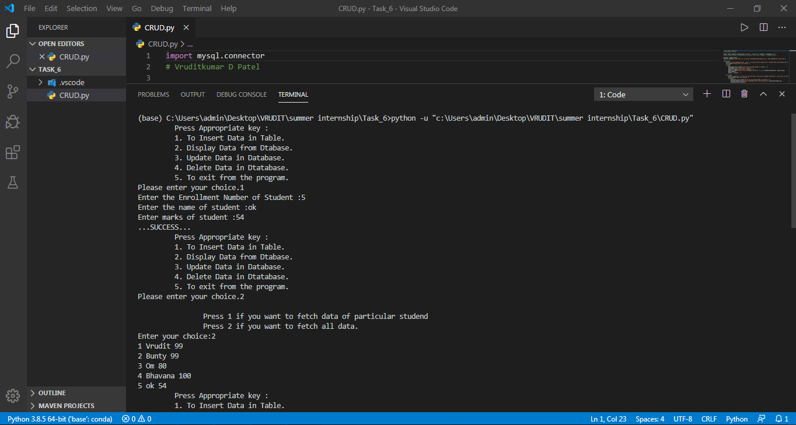

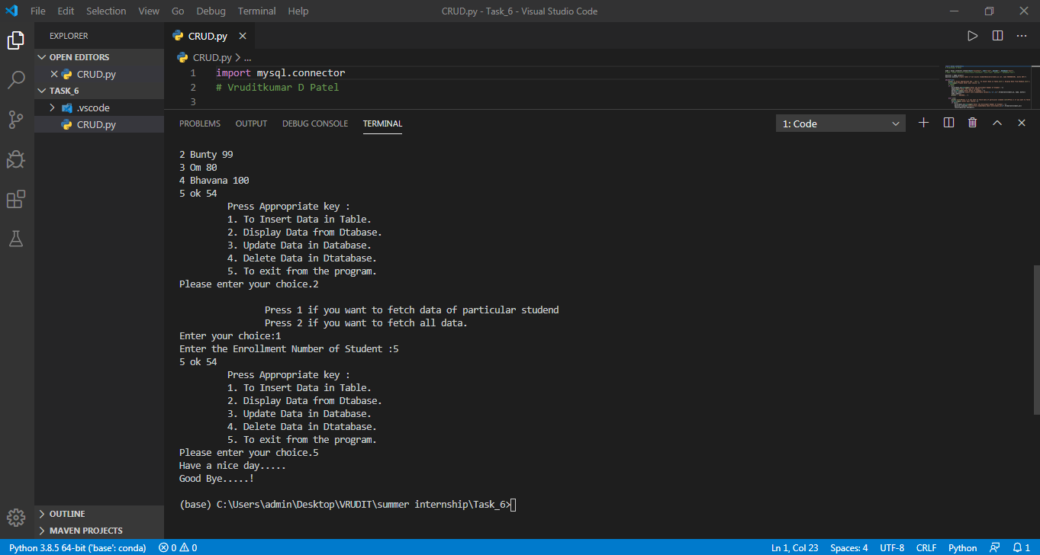

**(7). Selenium**

* The main function of selenium library is to test the software, However, we can also use selenium for implementation of automation using Python.
* In that session I learnt basic fundamentals of selenium and how to automatically search anything on Google using selenium.

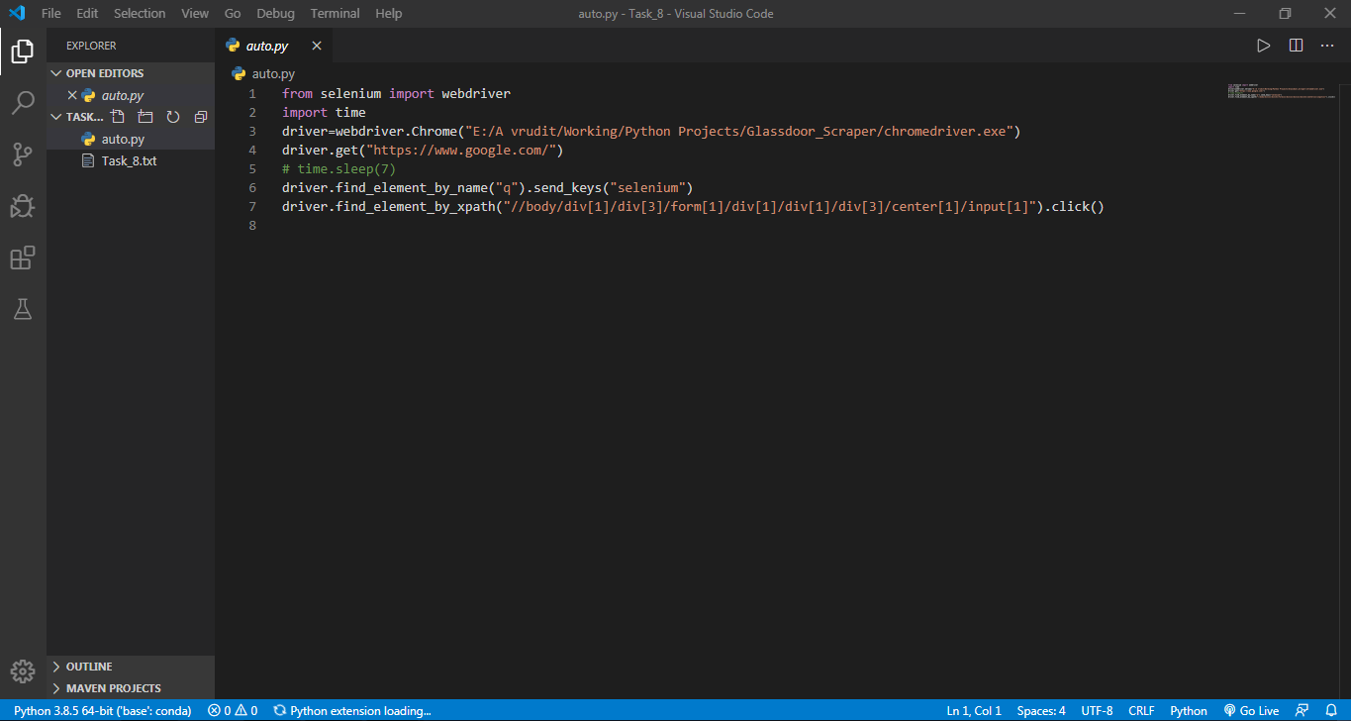

**OUTPUT :**

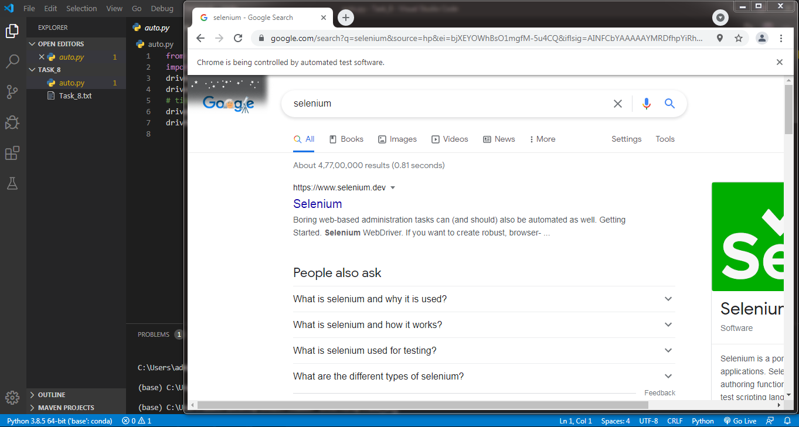

**(8).** **Django Basic**

* We learnt how to download django using pip command.
* Apart from this we also got to know how to make application inside django project using command prompt.
* How to run django server using “ python manage.py runserver ” .
* We can make any changes and we can register all those in settings.py file in main project folder.
* Whatever change we make, we have to define that in views.py and register in urls.py.
* As our app is register in our main project folder, every change in our app reflects in our main project.
* “ python manage.py runserver ” runs the django server on localhost at port number 8000.
* We can change port number as well.

Flie structure of django project :

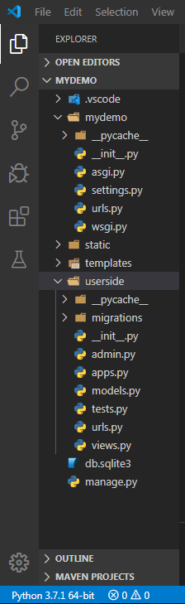

**manage.py :**

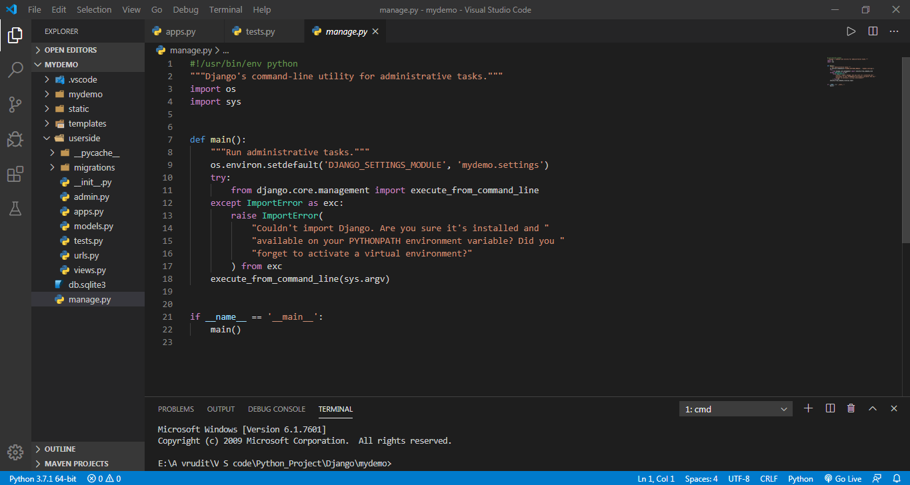

**urls.py :**

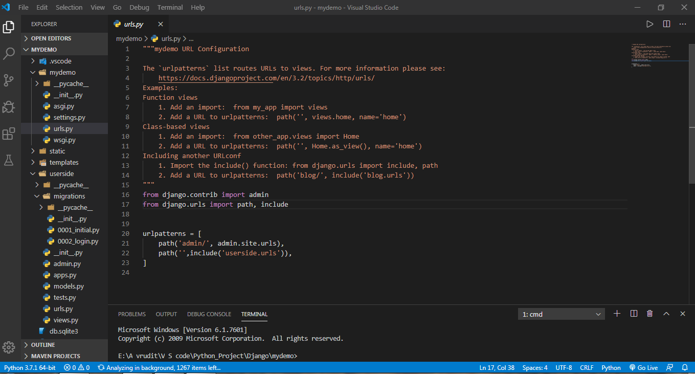

**setting.py :**

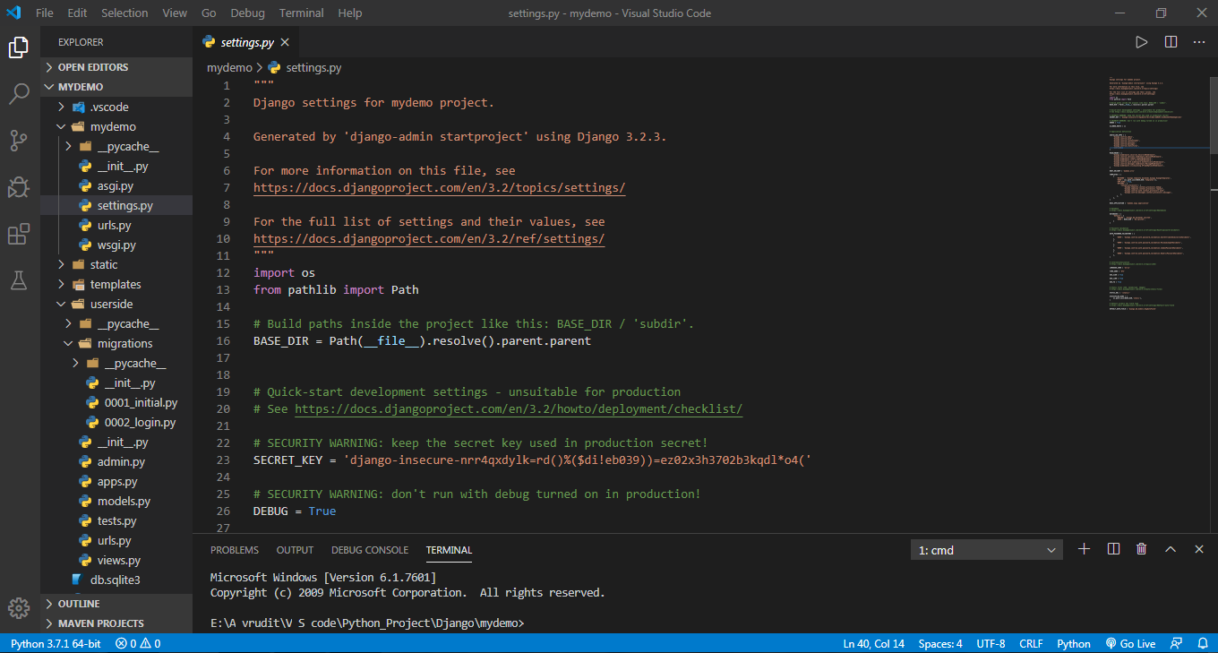

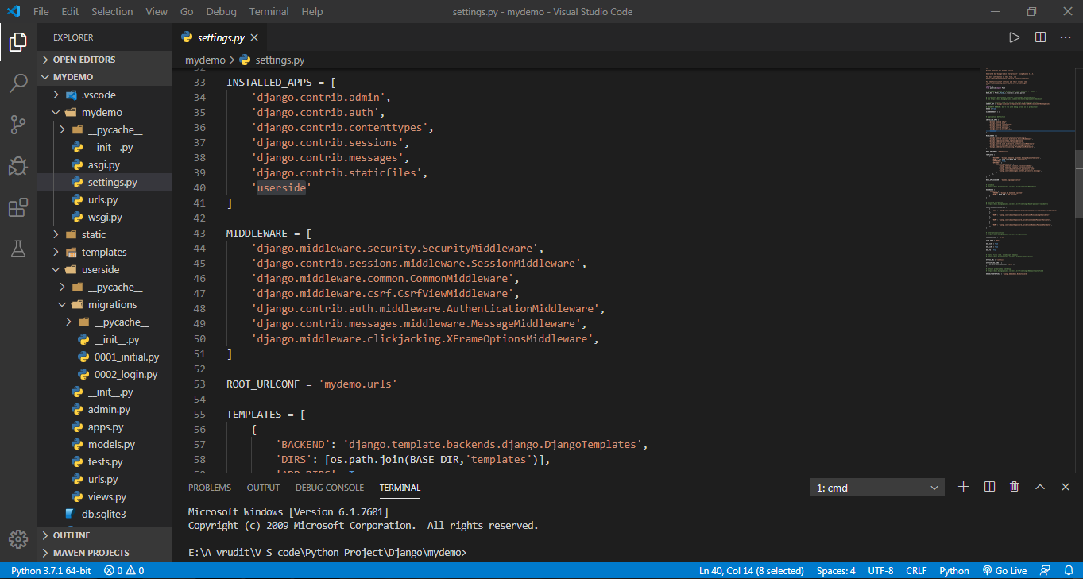

**urls.py ( userside application ) :**

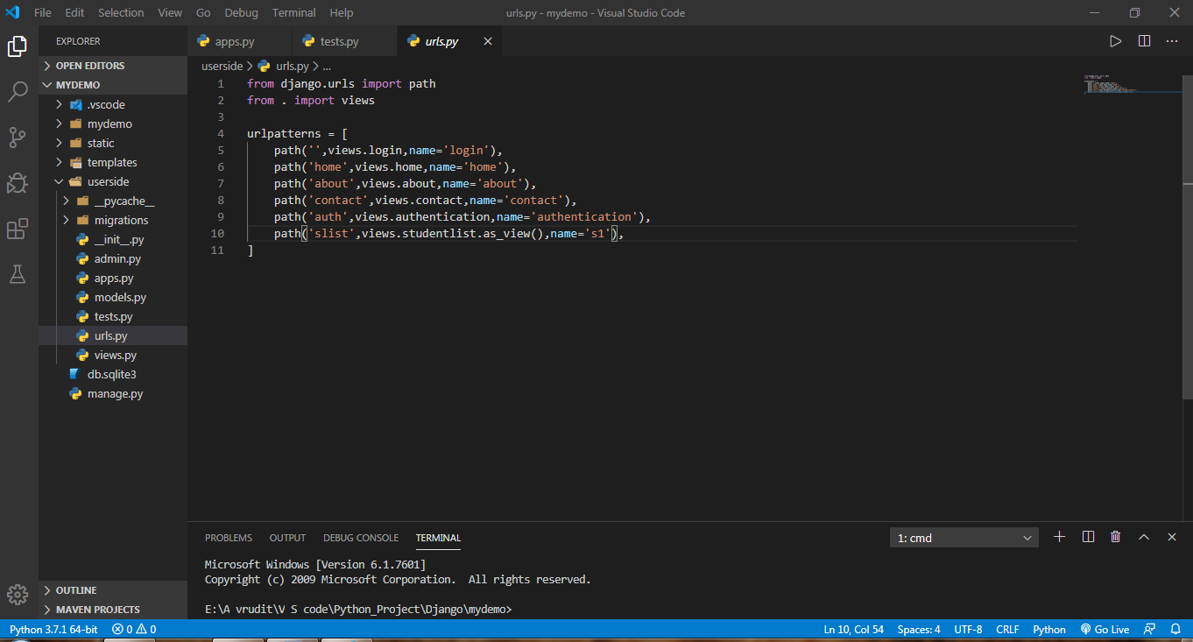

**views.py ( userside application ) :**

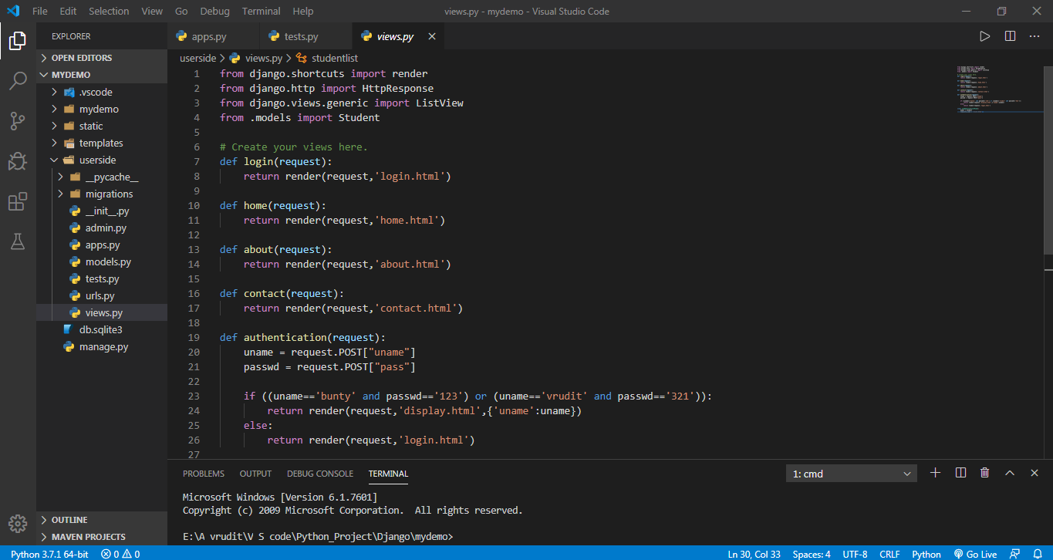

**apps.py ( userside application ) :**

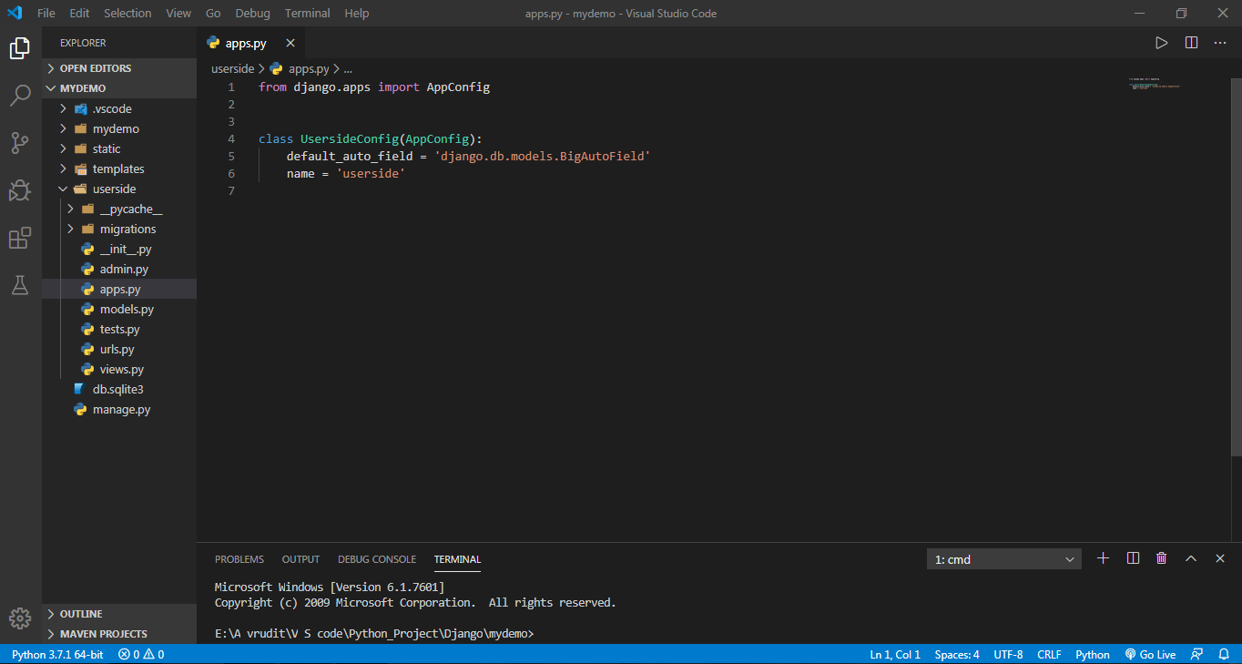

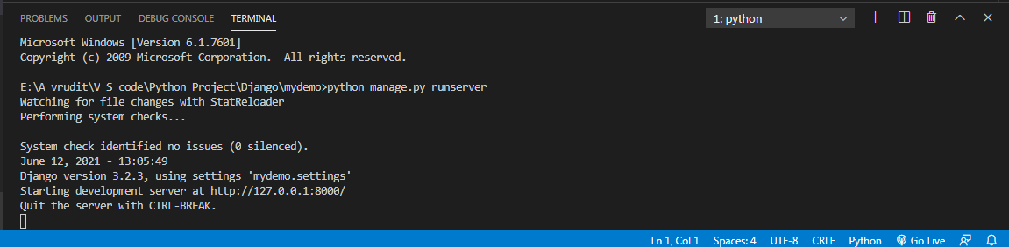

**(9). HTML Pages and Theme Integration in Django :**

* As we all know HTML pages play a crucial role in any website in terms of attraction and apealing feeling.
* Infact every website must contain certain HTML pages regardless of technology in which it is made i.e. Spring, Flask, Django, Servlet, etc.
* In Django also, we can put numbers of HTML pages in our website.
* But for that we have to follow well-define procedure.
* We have to create a separate folder named as “ **templates** ”.
* After that we have to register that folder inside **urls.py** and define that in **views.py.**
* In same way, we can use CSS as well.
* Above all, we can also integate a ready-made theme . scriplates are used for this purpose.
* In this session we downloaded one theme named “ **stampa-like** ” .
* First of all we had to downloaded zip file from its official website and afterwards we needed to unzip that file.
* By doing so, we get some folders containg pictures and css files.
* In my project that folder’s name is “**static**”.
* Whole process is wounderfully described on official webiste of Django.

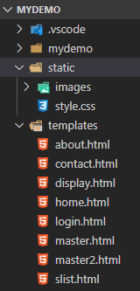

**master.html ( Theme ) :**

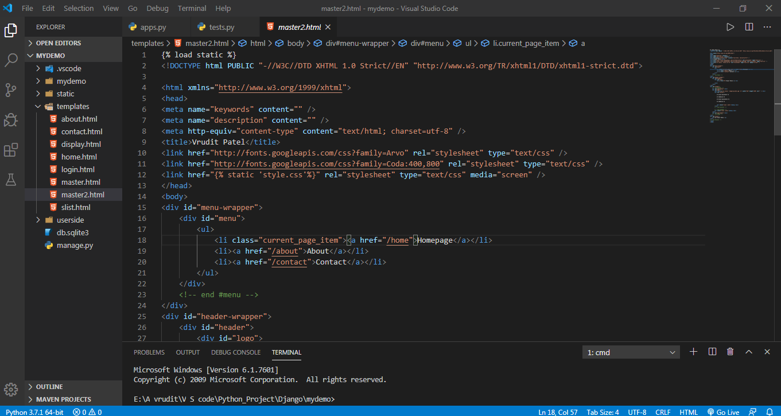

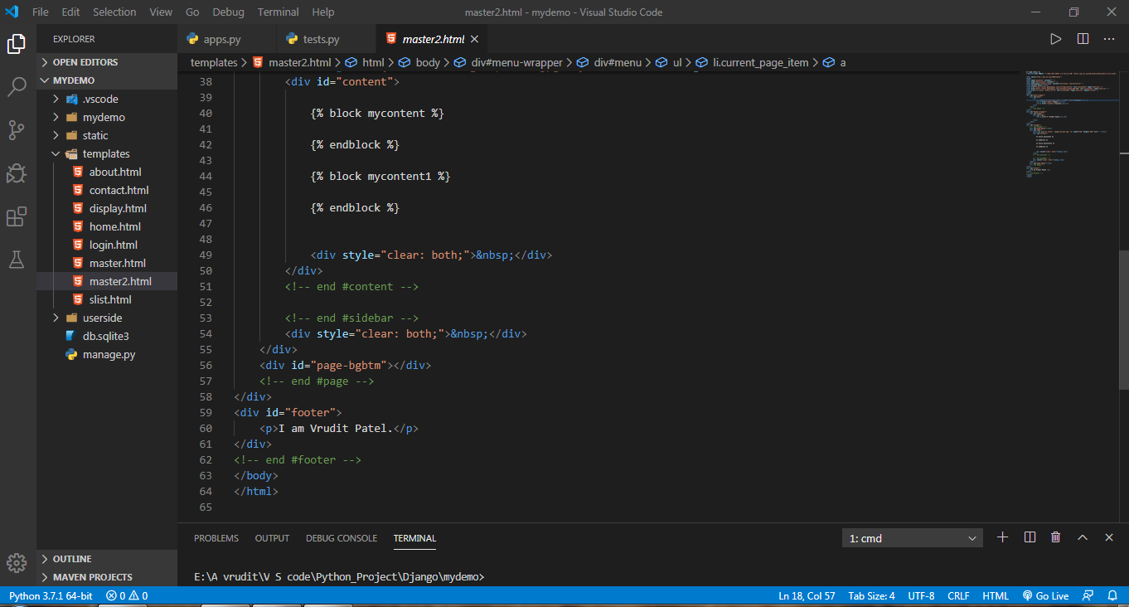

**about.html :**

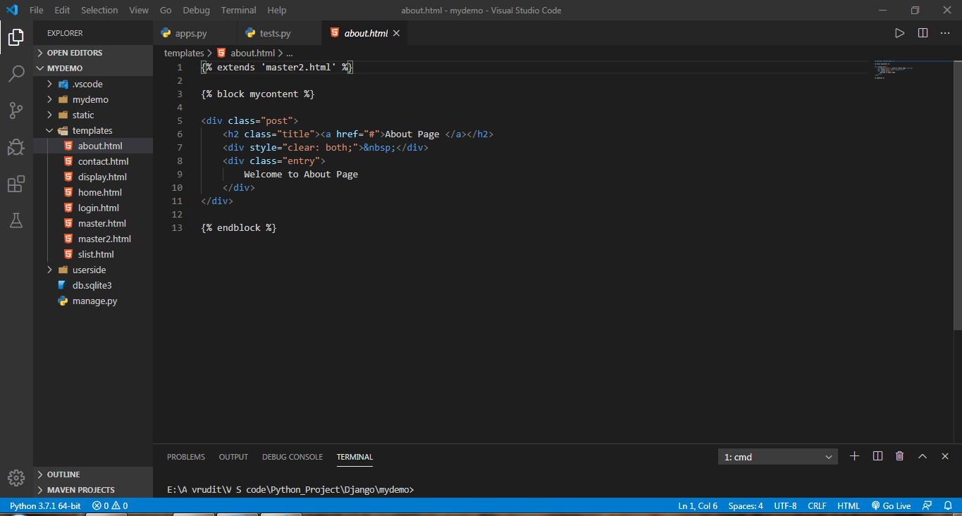

**Contact .html :**

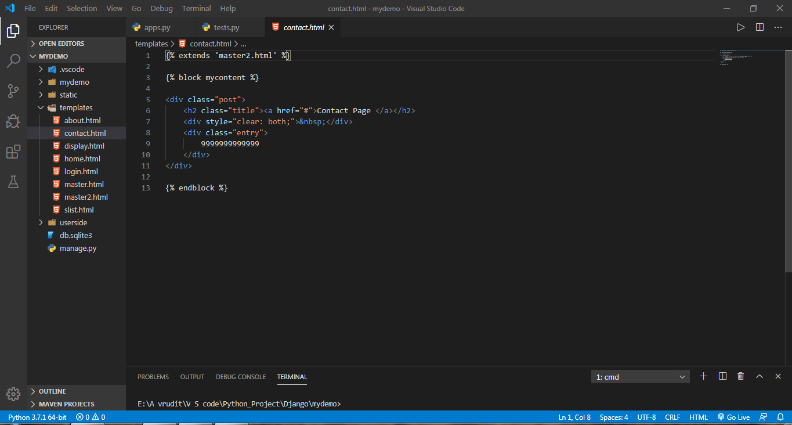

**Home.html :**

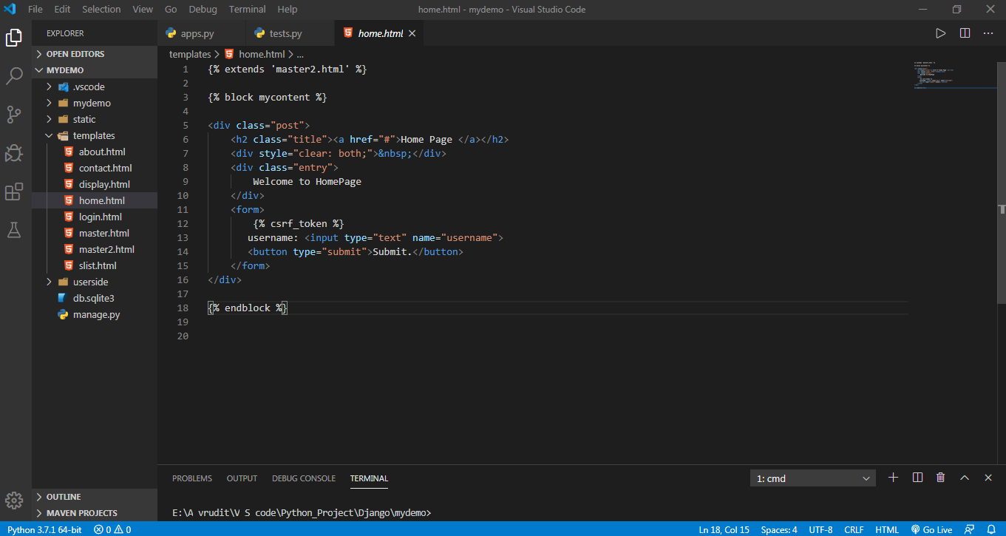

Output :



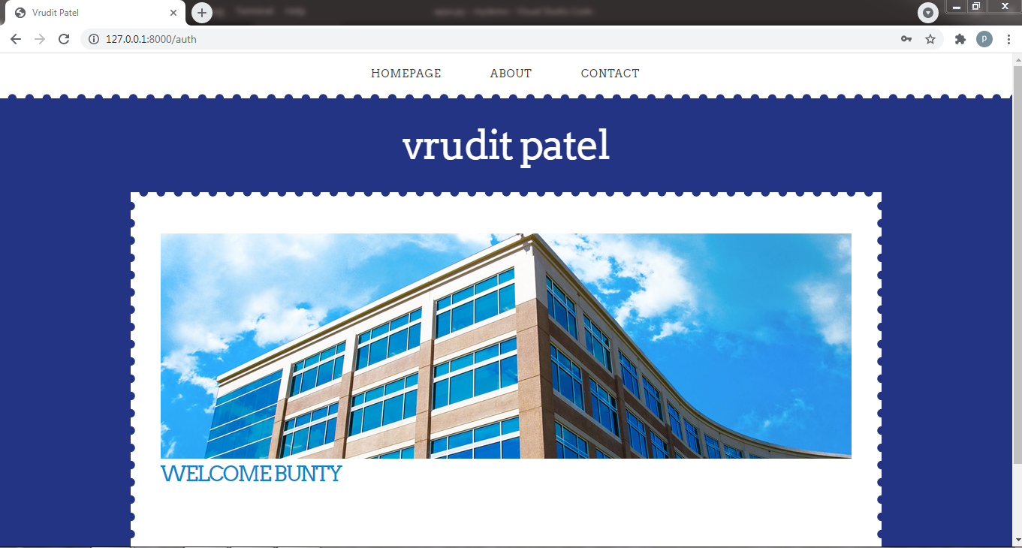



**(10). Login (authentication) feature in website :**

* Countless websites possess feature of  **Login.**
* In django also, we can implement this important feature.
* For that we have to take some inputs from the users as credentials.
* For example Username and Password.
* Then we can compare that username and password with correct credentials. On that basis, we can render the user anywhere else or desired webpage.
* In this particular website, I had implemented static feature means no databse needed for authentication.
* Here is the function for authentication :

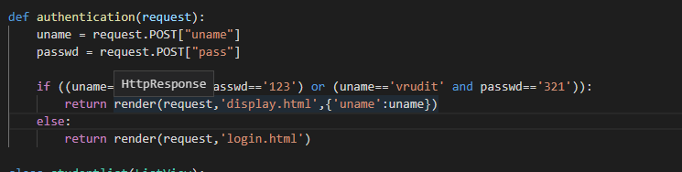

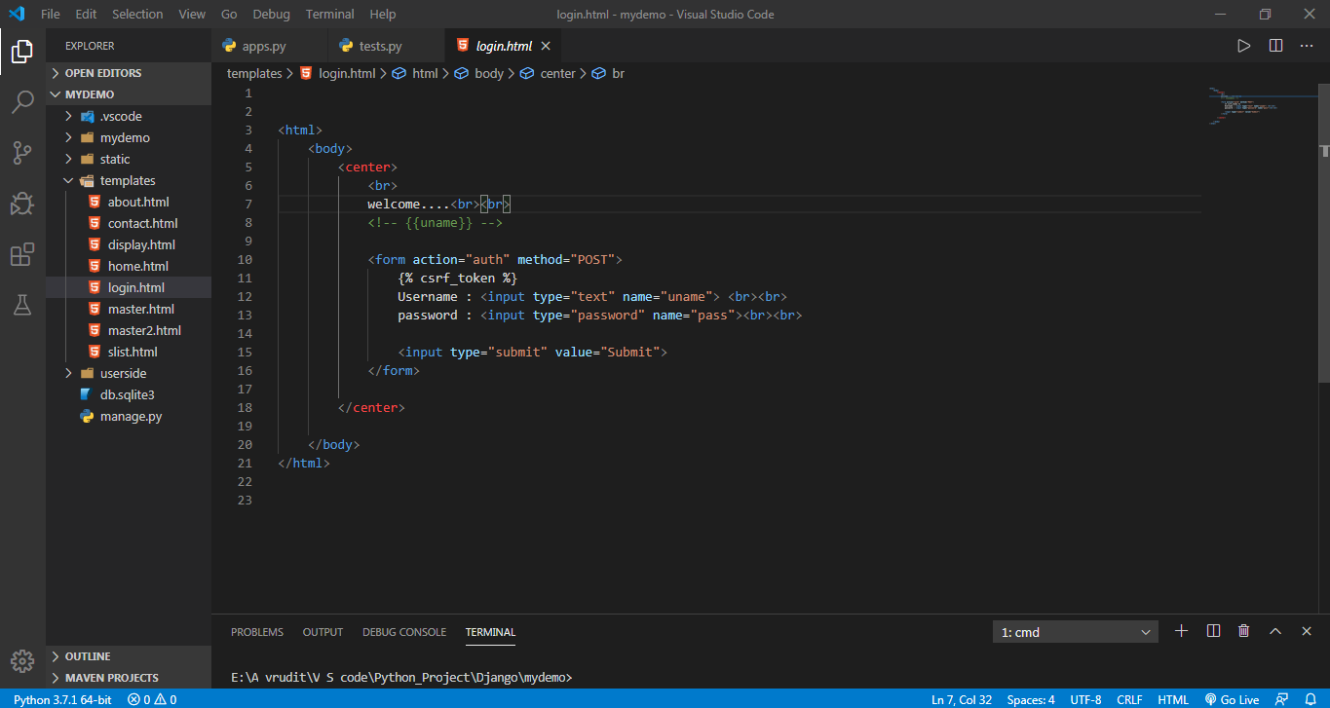

Output :

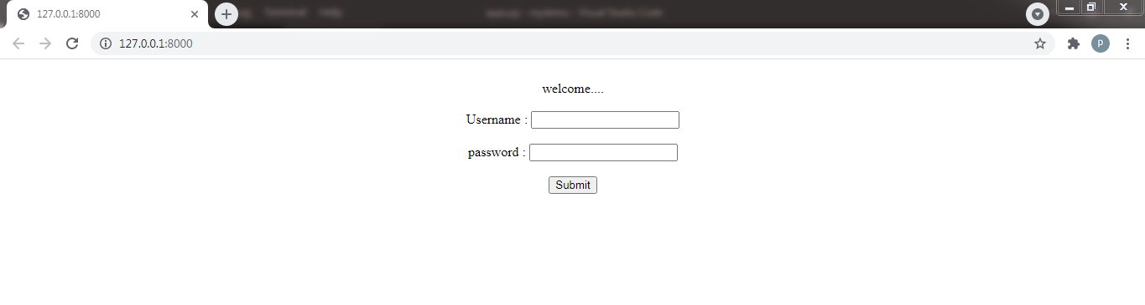

**(11). Admin panel and database (sqlite3) :**

* One of the most important feature is that django provide in-built **admin panel**
* Thus developers are not longer required to utilize resources in admin panel.
* Django’s admin panel is very easy to use and userfriendly.
* We can perform almost all tasks from that admin panel.
* But in order to access admin panel we have to become **Super User**.
* We can be super user from the command prompt.
* For database, Django initially provide a small database- **sqlite3**.
* Again to access that database we have to register in **settings.py** in main folder.
* Moreover, we have to create separate file named as  **model.py**.
* In this file we can create function for each table inside sqlite3 databse.
* In short, if we have 3 tables in database, then we have to make 3 functions in **models.py**.
* After creating or changing the model.py, we have to perform one more task and that is **migration**.
* We can do this task from the command prompt itself.
* The command is :
* **python manage.py makemigration**
* **python manage.py migrate**
* **folder structure :**

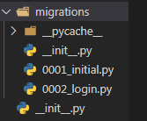

**UI of Admin panel :**

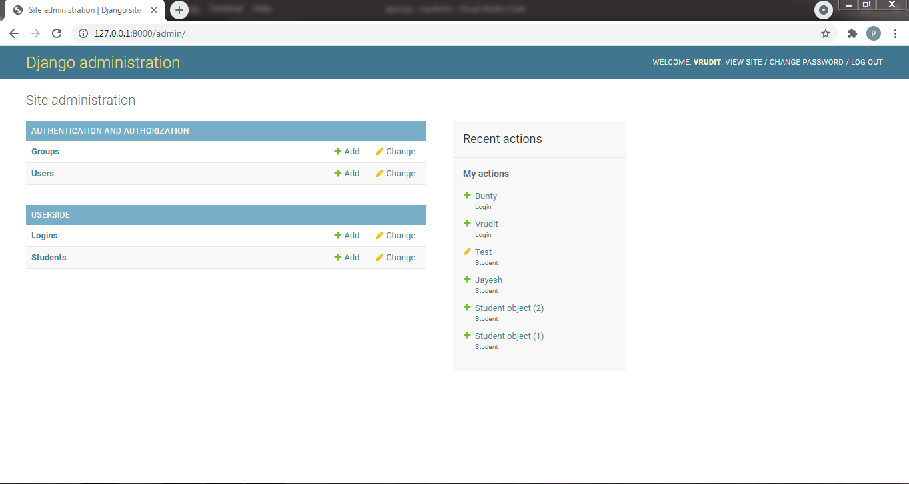

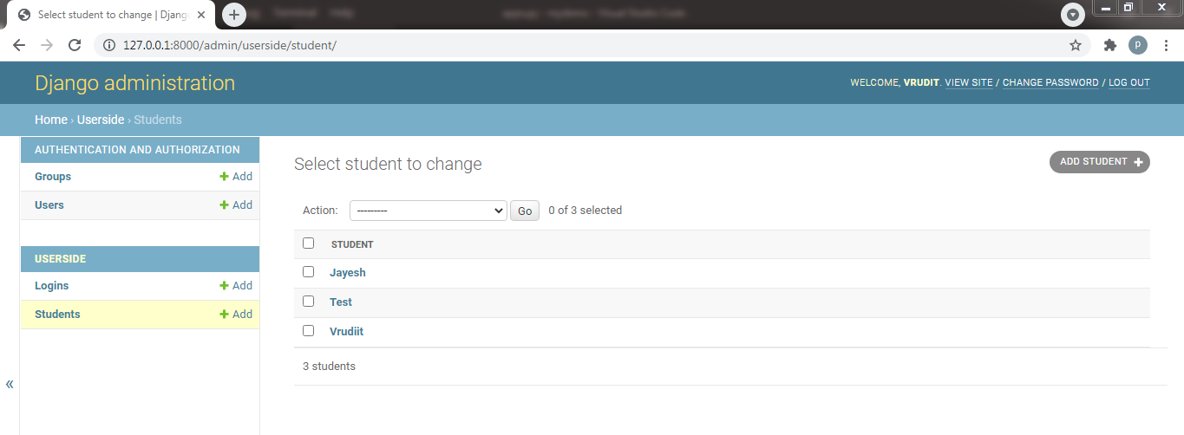

**model.py :**

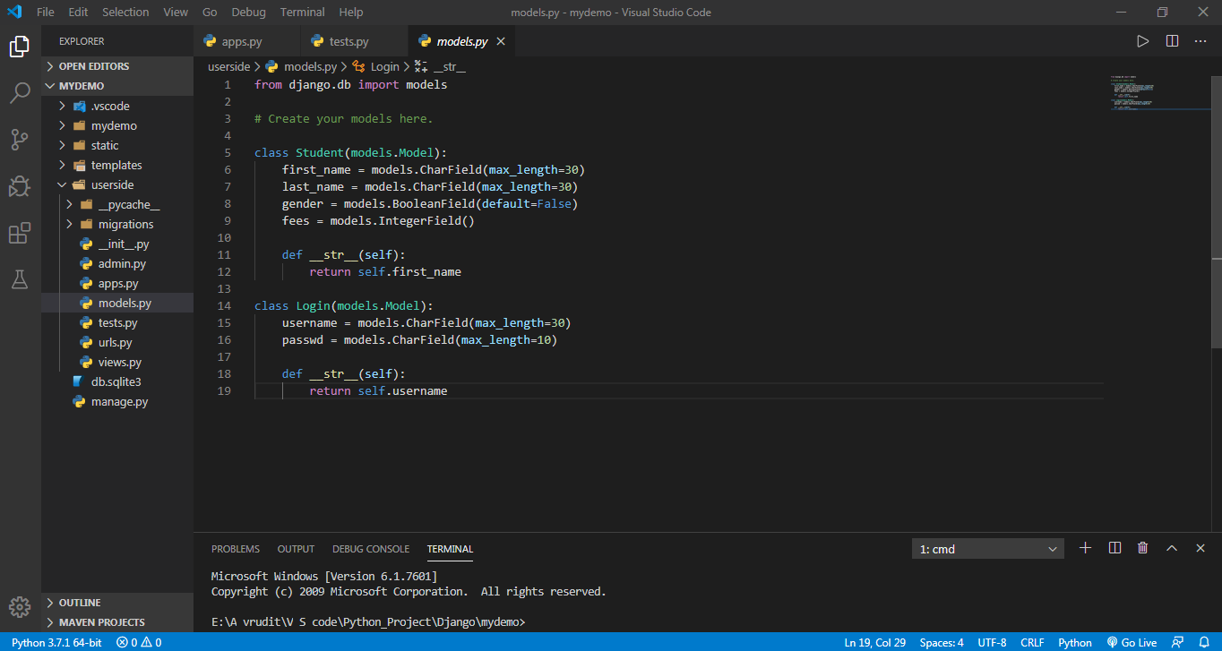

1. **Certificate from Company (Akash Technolabs)**

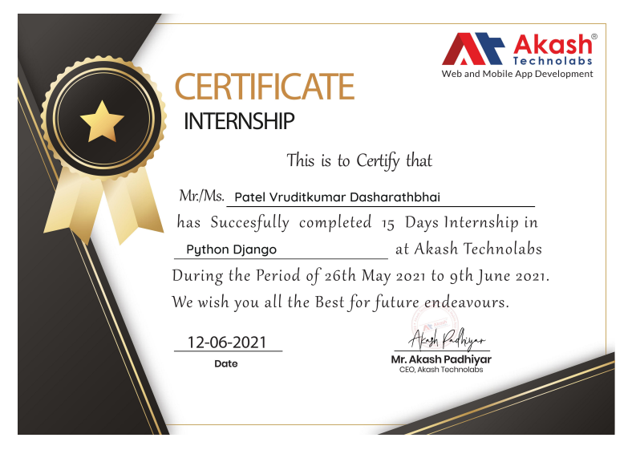

1. **Conclusion**

* In conclusion, I would like to say, Overall experience was very positive. I strongly deem that this experience will act as a stromg pillar of my bright future as this internship gave me a valuable experience of working in corporate world. Apart from this, I also got motivated experiencing next level work pressure. I can say I got many cognitive skills, soft skills and technical skills ofcourse. What is more, I understood the working pattern of one ordinary IT company and upcoming trends of this unstable digital world.
* Now I cam shape my self according to corporate world and I can learn only important stuff instead of weasting time and resouces behind some technologies in which I am not interested. I like to consider this internship as a initial and fundamental step of my career.
* Completing this internship I came to know that django is such powerful and most appropriate technology for web development. As this is open source technology we can expect further development in this field of django and will get attractive features in upcoming days.
* **I want to thank GTU specially** for introducing this subject in our syllabus, sooner or later we and GTU will get positive outcomes of this subject definitely.
* I am thankful of **Akash Padhiy**ar sir(External Guide) and **Akash Technoabs** for providing platform for internship and giving me a life long experience.
* I also want to thank my **internal** guide who helped me and guide me throught the internship and giving me some valuable lessons.